**Software Engineering Assignment**

**SE – Overview of IT Industry**

**Module – 1**

**Name :- Abhay Gajjar**

**Question 1** : **What is a software ? What is a software engineering ?**

**Answer** : software is a computer program that provides a set of instructions to execute a user’s commands and tell the computer what to do. For example likeMS-WORD , MS-EXCEL , POWERPOINT etc.

* Software engineering is the branch of computer science that deals with the design, development, testing, and maintenance of software applications. Software engineers apply engineering principles and knowledge of programming languages to build software solutions for end users. For example like :
* Requirement analysis
* Design
* Implementation
* Testing
* Maintenance

**Question 2** **: Explain types of software ?**

**Answer** : There 5 types of software :

1. System Software
2. Application software
3. Driver software
4. Middleware
5. Programming software
6. **System Software :**

These software programs are designed to run a computer’s

Application programs and hardware.

System software coordinates the activities and functions of

the hardware and software.

It controls the operations of the computer hardware and

Provides environment or platform for all the other types of

Software to work in.

The OS is the best example of system software ; it manages all the other computer programs.

Example = Notepad, Calculator etc.

1. **Application Software :**

Application software is a computer software pacakge that performs a specific function for a user , or in some cases, for another application.

An application can be self-contained, or it can be group of programs that run the application for the user.

Examples of modern application include office suites, graphics software, databases and database management programs, web browsers, word processers, software development tools, image editors and communication platforms.

Exaple = Microsoft Office, Paint, Powerpoint etc.

1. **Driver Software :**

Device drivers control the devices and peripherals connected to a computer, enabling them to perform their specific tasks.

Every device that is designed to a computer needs at least one device driver to function.

Examples include software that comes with any nonstandard hardware, including special game controllers, as well as the software that enables standard hardware, such as USB storage devices, keyboards, headphones and printers.

Example : Audio Driver, Video Driver etc.

1. **Middleware :**

Middleware software that mediates between application and system software or between two different kinds of application software.For examples, middleware enables Microsoft Windows to talk to excel and word.

It is also used to send a remote work request from an application in a computer that has one kind of OS , to an application in a computer with a different OS.It also enables newer applications to work with legacy ones.

Example : Database middleware, application server middleware.

1. **Programming Software :**

Computer programmers use programming software to write code. Programming software and programming tools enable developers to develop, write, test and debug other software programs.

Examples of programming software include assemblers, compilers, debuggers and interpreters.

Example : Tubro, Eclipse, Sublime etc.

**Question 3 : What is SDLC? Explain each phase of SDLC ?**

**Answer :** Software Development Life Cycle is a process that produces software with the highest quality and lowest cost in the shortest time possible. SDLC provides a well-structured flow of phases that help an organization to quickly produce high-quality software which is well-tested and ready for production use. **There are 6 Types of SDLC :**

1. **Planning / Requirement Gathering :**

The first stage of the SDLC is planning. The purpose of this stage is to develop a basic plan about what an application needs to do based on business requirements.

1. **Analysis :**

The analysis stage of the SDLC is where development teams translate high-level plans and goals into actionable ideas. To do this, teams perform a technical analysis of the plans they developed in the previous stage and determine how best to implement them.

1. **Design :**

The design stage focuses on deciding how the application behaves and what it looks like from the user's perspective. For example, if the application has a GUI, teams should sketch what that interface looks like in this stage. Teams should also consider whether users need to register accounts to use the app and, if so, whether there are different types of accounts, such as admin and nonprivileged accounts, for different users.

1. **Implementation/Coding/building :**

The implementation stage -- also sometimes referred to as the *development* or *coding stage* -- is where teams write the actual code. This can be the lengthiest stage of the SDLC if there is a lot of complicated code to write. But it can also be relatively short, especially if teams accelerate code implementation using methodologies such as low-code/no-code.

1. **Testing :**

After teams have written code, they're ready to test it. Teams should design tests that align with the goals established during the first three stages of the SDLC. After they design the tests, teams should run the tests and identify results that don't meet expectations. If an application doesn't pass all tests, teams may need to update some of the code from the previous stage to fix the issue and then run the tests again.

1. **Maintenance :**

The final stage of the SDLC is maintenance. The main goal of maintenance is to monitor the application on a continuous basis to identify issues that arise once it is in production. For example, if a certain type of request triggers an error, development teams should note that so they can fix the issue.

**Question 4 : What is DFD? Create a DFD diagram on Flipkart?**

**Answer :** Data Flow Diagram (DFD) represents the flow of data within information systems. Data Flow Diagrams (DFD) provide a graphical representation of the data flow of a system that can be understood by both technical and non-technical users.

* 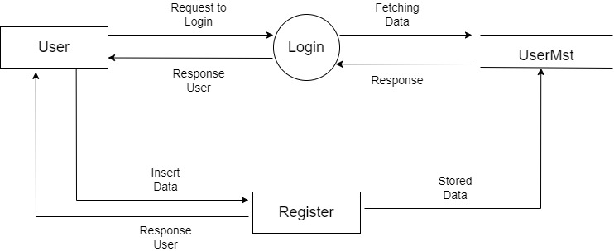**DIAGRAM : ( Level 0 DFD of Login in Flipkart )**
* 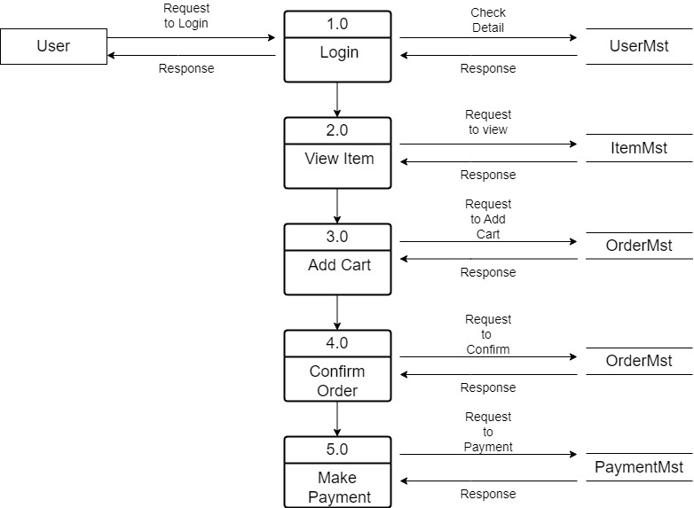**DIAGRAM : (Level 1 DFD of Buying Product From in Flipkart)**
* 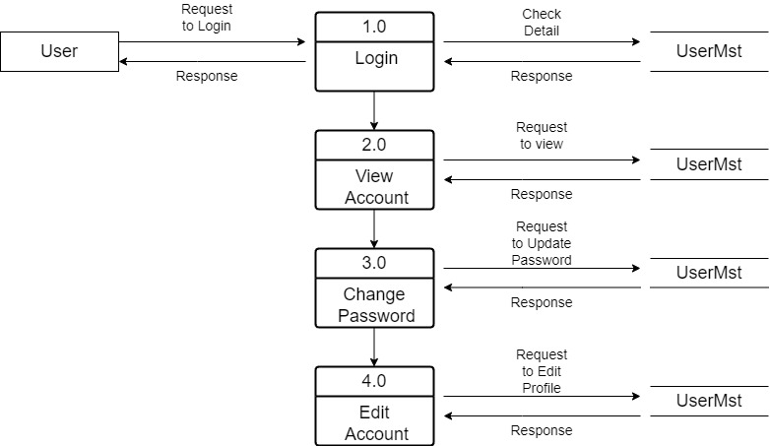**DIAGRAM : (Level 2 DFD View and Edit Account in Flipkart )**

**Question 5 : What is Flow chart? Create a flowchart to make addition of two numbers ?**

**Answer :** A flowchart is a type of diagram that represents a workflow or process. A flowchart can also be defined as a diagrammatic representation of an algorithm, a step-by-step approach to solving a task.

* **FLOWCHART :**

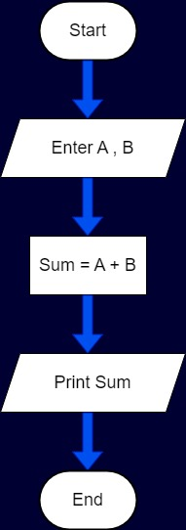

* **ALGORITHAM :**

**Step 1 :** Start

**Step 2 :** Read a & b

**Step 3 :** c = a + b

**Step 4 :** Display c

**Step 5 :** Stop.

**Question 6 : What is Use case Diagram? Create a use-case on bill payment on paytm ?**

**Answer :** A Use Case Diagram is a type of Unified Modeling Language (UML) diagram that represents the interaction between actors (users or external systems) and a system under consideration to accomplish specific goals. It provides a high-level view of the system’s functionality by illustrating the various ways users can interact with it.

* **Use-case on bill payment on paytm :-**

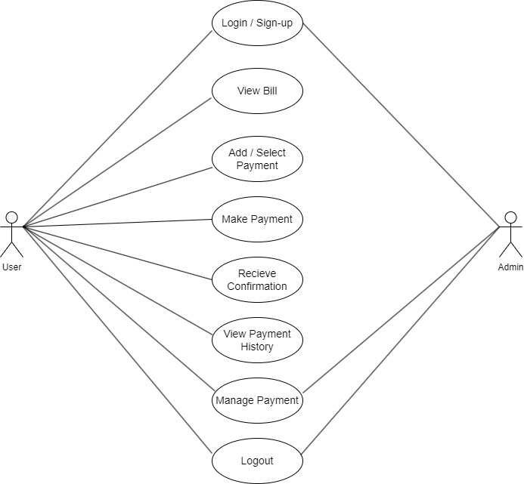

1. **Actors:**
   * User: The primary actor who interacts with the Paytm system to perform various tasks related to bill payment.
2. **Use Cases:**
   * Login/Sign Up: The process for users to log in to their Paytm account or create a new one.
   * View Bill: Allows the user to view their bill details.
   * Add/Select Payment Method: The user adds a new payment method or selects an existing one.
   * Make Payment: The process where the user completes the payment for the bill.
   * Receive Confirmation: The confirmation message or receipt the user receives after a successful payment.
   * View Payment History: Allows the user to view their past payment history.
   * Manage Account: Provides functionality for users to manage their account details such as personal information or payment settings.
3. **Interactions:**
   * The diagram shows the interactions between the user and the different use cases within the Paytm system.
   * It depicts the sequence of actions the user would typically follow, starting from logging in to managing their account and viewing payment history.

T This use case diagram helps in understanding the different functionalities involved in the bill payment process on Paytm and how the user interacts with the system to complete their tasks.